Post Details | Last Updated: October 2025
Faculty/Administrative/Service Department | Research, Innovation and Impact (RII)
Job Title | Innovation Support Officer
Job Family | Professional | Job Level | 3
Responsible to | Senior Project Officer (Innovation) & MD Innovate Surrey Ltd
Responsible for (Staff) | No staff report to this post
Job Purpose Statement

The Innovation Support Officer is a key member of the Innovate Surrey Ltd (ISL) team contributing to the delivery of the University’s Vision 2041 strategy to be recognised internationally as a hub for game-changing innovation. ISL’s mission is to deliver this goal by supporting the effective translation and commercialisation of university research into impactful technologies and commercial solutions that address key societal challenges.
Working within the ISL team, the postholder will work under the direction of both the Senior Project Officer (Innovation) and MD of ISL to provide administrative, project and finance support to the ISL team. The postholder will also work with a wider network of specialist innovation and engagement support teams and central administrative teams across the University.
The postholder will sit within the Innovation Support Office team (~3 FTE), which provides key services to support innovation activity across the PVCRI portfolio of directorates. Whilst service delivery is shared amongst the team, this post is focused on providing the wider ISL team with administrative, project and finance support.

Key Responsibilities
- Technology Transfer project support / coordination – including provision of specific support to the ISL team; supporting various stages of the technology transfer lifecycle, through data collation, analysis and reporting, co-ordination & support for team meetings, and input to specific project activity;
- Internal events / workshops co-ordination – including external guest coordination; event planning & management, both calendar-driven/ ad-hoc;
- Marketing & Communications – including management of internal/external newsletters, crafting content, producing marketing materials and handling communications to external partners; managing social media posts; working closely with the University’s Central Marketing & Communications team;
- Information management and Digital content – including data management for reporting, supporting the IP Manager in managing the technology transfer pipeline database; maintaining the digital assets and websites; maintaining the ISL KPI metric databases with effective data entry;
- Financial support – including processing orders, forecasting, budget monitoring and reporting;
- Office management – including diary management for the MD of ISL, handling and filtering queries and general requests; setting up meetings, taking minutes, arranging travel, processing expenses, supporting the effective utilisation of facilities, coordinating to ensure these are maintained, and set up with appropriate services;
- Adhoc support – including supporting and administering recruitment activities; process support and coordination for inductions, health and safety training, and development;

N.B. The above list is not exhaustive.

All staff are expected to:
- Positively support equality of opportunity and equity of treatment to colleagues and students in accordance with the University of Surrey Equal Opportunities Policy.
- Work to achieve the aims of our Environmental Policy and promote awareness to colleagues and students.
- Follow University/departmental policies and working practices in ensuring that no breaches of information security result from their actions.
- Ensure they are aware of and abide by all relevant University Regulations and Policies relevant to the role.
- Undertake such other duties within the scope of the post as may be requested by your Manager.
- Work supportively with colleagues, operating in a collegiate manner at all times.

Help maintain a safe working environment by:
- Attending training in Health and Safety requirements as necessary, both on appointment and as changes in duties and techniques demand.
- Following local codes of safe working practices and the University of Surrey Health and Safety Policy.
Elements of the Role

Planning and Organising

- The postholder will work closely with the MD of ISL to understand the needs of the ISL team and respond accordingly. Once they have received direction, they will be expected to work with minimal supervision, feeding back if they encounter problems/issues that they are unable to solve on their own.
- The postholder will work on a range of tasks concurrently and must therefore operate flexibly and react positively to changing circumstances and requirements.
- Working with minimal supervision the postholder will be required to apply judgement and initiative when managing their workload, including any medium-term priorities.
- The postholder will be responsible for organising their time so that they can deal with conflicting priorities and will need to demonstrate a considerable level of flexibility in order to respond to any unforeseen problems.

Problem Solving and Decision Making

- Although the postholder will work within a framework of existing processes and policies, they have the freedom to take a proactive approach to problem solving and have the delegated authority to resolve problems using their judgement and experience to make appropriate decisions.
- The nature of the work expected also means that the postholder may be expected to complete tasks or contribute to activities that are new, and therefore fall outside of established procedures. The postholder will be expected to suggest and implement solutions where appropriate.
- Day to day issues are likely to be varied, and problem solving and decision making at different levels will be an ongoing requirement. The postholder will need to respond positively and flexibly to changing circumstances and requirements. It is therefore expected that the postholder will communicate with the MD of ISL and the Senior Project Officer (Innovation) if they are unsure how best to resolve an issue and/or prioritise their workload.
- The postholder will be required to analyse problems of which they may have little or no experience, and are responsible for conducting the necessary research to provide solutions, referring to relevant policies and procedures as required. If the problem requires more senior attention, it can be referred to the Senior Project Officer (Innovation), the postholder is however expected to have a degree of autonomy in finding and implementing resolutions in this case.
- The postholder may have access to sensitive external and internal information and will be required to keep such information confidential, referring to the appropriate manager if in doubt.

Continuous Improvement

The postholder will be expected to review current procedures and suggest changes that improve the service and facilitates sustainability. Improvements will require the approval of the MD of ISL, to ensure they fit within the current programme and budgets before implementation.

Knowledge transfer, sharing of best practice, and process transparency are key benefits of establishing the Innovation Support Office. As such, the post holder will actively be engaged in exchanging ideas with the team on continuous improvement for their skillset, and documenting these processes for awareness.

Accountability

The postholder will operate with minimum day-to-day supervision in the day-to-day planning, organising and performance (to an agreed quality standard and specification by the MD of ISL) of a wide range of activities in support of ISL and the wider Innovation Support community.

Dimensions of the role

- The postholder will work flexibly across the Innovation Support team, and may on occasion support service provision across the wider PVCRI portfolio.
- The postholder will work within a team of Support Officers, who together cover the most common/ in demand Innovation Support requirements for the PVCRI portfolio.
- They may be assigned to projects according to their personal specialism, which are aligned to their skills and experience, but will be expected to work collaboratively across other projects, in a flexible and agile way, as needed.
- They may work on multiple projects simultaneously.
- They will deal with uncertainty – handling requests and queries.
- They will provide short term, short notice support to other activities where constraints demand extra resource, as guided by the Team Manager.
- The post holder does not have any budgetary or supervisory responsibility.

Supplementary Information

The postholder will work flexibly across a range of projects, as part of the Innovation Support team, to provide administrative, project and finance support to the ISL team and the MD of ISL. Although part of the RII Innovation Support Office, it is expected that the post holder will have a predominant skillset from one of the following key areas of responsibility, and be able to support service provision in at least 1-2 additional areas:

Person Specification
Qualifications and Professional Memberships
HNC, A level, NVQ 3, HND level or equivalent with a number of years' relevant experience.  Or: Broad vocational experience, acquired through a combination of job-related vocational training and considerable on-the-job experience, demonstrating development through involvement in a series of progressively more demanding relevant work/roles |  | E
Technical Competencies (Experience and Knowledge) | Essential/  Desirable | Level  1-3
Proficient IT skills, including use of MS Word, Excel, Outlook and PowerPoint | E | 3
Knowledge of relevant business processes | E | 3
Experience of database entry with proven attention to detail and accuracy | E | 3
Experience of relevant University systems, e.g. Agresso Finance system, PeopleSoft/ SAP HR system, Inteum IP system, etc | D | n/a
Special Requirements: |  | Essential/  Desirable
You may occasionally be required to provide support outside of your normal working hours and /or place of work. This would be by agreement with your line manager |  | E
Core Competencies |  | Level  1-3
Communication  Adaptability / Flexibility  Customer/Client service and support  Planning and Organising  Continuous Improvement  Problem Solving and Decision Making Skills  Managing and Developing Performance  Creative and Analytical Thinking  Influencing, Persuasion and Negotiation Skills  Strategic Thinking & Leadership |  | 3  3  3  2  2  2  n/a  1  1  n/a
Organisational/Departmental Information & Key Relationships

Background Information

ISL is part of the PVCRI portfolio and focuses on delivering impact at scale from the translation and commercialisation of University of Surrey research outputs.

Department Structure Chart

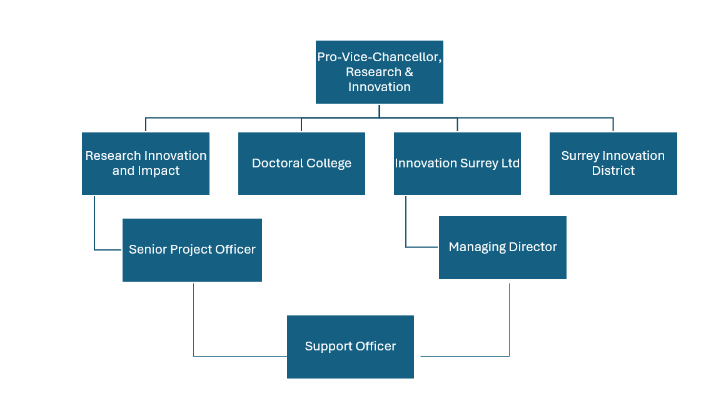

Relationships

The postholder will deal with visitors and provide/request information from internal and external contacts in a courteous manner in order to promote a professional image of ISL. They will liaise and build relationships with other University departments as well as external contacts, including company representatives, visitors from other universities and institutes, external consultants and agencies.

Internal
- ISL team
- PVCRI portfolio Directors, their Senior Management and teams: Research, Innovation & Impact; Surrey Innovation District; Doctoral College
- Office of Pro-Vice-Chancellor, Research & Innovation (PVCRI)
- Professional Services departments
- Faculty project support staff, Faculty Research & Innovation Managers

External
- ISL Mentor, partner and investor networks
- External suppliers for booking or ordering goods and services

